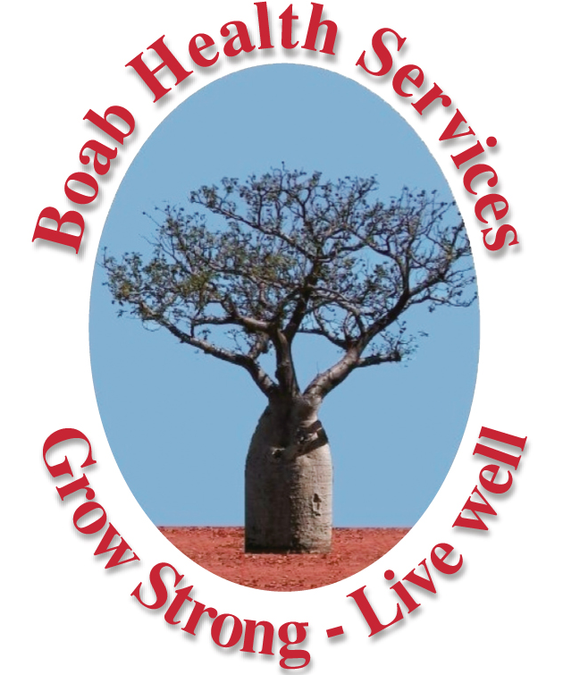

Job Description and Duty Statement

Position Title | Youth & Community Support Coordinator - ABLe Program
Organisation | Boab Health Services Pty Ltd
Status of employment | Full - Time to 30 June 2019  Continuation of contract subject to ongoing funding
Hours of employment | 1.0 FTE (75 hours per fortnight) Full Time
Reports to | Youth Mental Health Team Leader – East Kimberley
Salary | Salary: $93,440 - $99,335 per year  Salary - commensurate with skills and experience.
Location | Wyndham

Entitlements
- 6 weeks Annual Leave (Pro rata)
- Professional Development Assistance
- Ability to Salary Package

About Boab Health
Boab Health Services Pty Ltd is a not-for-profit primary health care organisation servicing the Kimberley region of Western Australia. Services include allied health, mental health, the “Closing the Gap” initiative and a range of health promotion programs. Boab Health Services delivers these services from centres in Broome and Kununurra with outreach to the wider communities in the Kimberley. For further information about the services we provide visit our website www.boabhealth.com.au.

As a member of the Youth Mental Health Services Team you will provide Mental Health support services and casework around practical issues of everyday life that underpin well being, to clients accessing the ABLe (A Better Life) Program. As part of a support package for the cashless debit card trial in Wyndham, ABLe services will support people (16 years to 65 years of age) with mental illness that includes drug and alcohol use disorders and/or gambling disorders.

All members of the Mental Health Team work together to deliver outcomes consistent with the company’s Strategic Plan, Business Plan, Annual Operational Plan in support of Boab as a Primary Health Care organisation.

Position Details
The Community Mental Health Officer (CMHO) position will work closely with and support the Youth Mental Health Team Leader & Mental Health Manager in provision of services to the town of Wyndham in the East Kimberley.

Job Description
The CMHO’s duties will include:
- Supporting and case managing the recovery of people impacted directly or indirectly by mental illness that includes drug and alcohol misuse and/or gambling disorders.
- Undertaking community outreach activities to identify and connect with potential participants and build strong referral networks.
- Manage entry to the ABLe Program through eligibility assessments.
- Work with eligible individuals to develop Individual Recovery Plans which focus on their goals and recovery journeys. Recovery Plans are to be reviewed at least every 3 months.
- Provision of intensive one-to-one assistance to support participants to achieve priorities and goals identified in their Individual Recovery Plans. This can Include:
  - Assisting participants to access required support from health, mental health, drug and alcohol, employment, financial counselling and accommodation services.
  - Helping participants to navigate mental health and community support services.
  - Collaboration with relevant service providers and agencies to ensure a coordinated response to needs and goals identified in each participant’s Individual Recovery Plan.
  - Helping participants to better manage their daily activities such as making and attending appointments, domestic routines and self-care.
  - Assisting participants to attend rehabilitation or other clinical services by arranging or providing transport where necessary.
  - Counselling, personal support and family interventions (for example conflict resolution or interpersonal skills development).
  - Provision of information in relation to mental health and help to develop strategies to maintain wellness.
  - Social inclusion and community engagement activities.
- Facilitation of better access to appropriate services including alcohol and other drug rehabilitation, and financial capability services.
- Facilitate the development of coping and problem solving skills in clients.
- Offering increased community participation opportunities (both social and economic).
- Prioritisation and active targeting of priority target groups as stipulated in the “A Better Life Operational Guidelines.”
- Promotion of the ABLe initiative throughout the community and ensuring that services are accessible. This may include and open door approach, outreach, drop–in and appointment services.
- Active targeting of potential participants who are difficult to reach or may not otherwise seek assistance.
- Liaison with other key stakeholders and assistance with other Mental Health initiatives within Wyndham/East Kimberley region.
- Gathering of data and information required for 3 monthly reports.
- Building of relationships within the community to facilitate development of rapport and trust.
- Recording of clinical notes into the MMEx database.
- Reporting as per Department of Social Services Data Exchange Protocols.
- Compliance with Boab Health Services policies and procedures regarding client file documentation in support of best practice.
- Distribution of information/resources to local Aboriginal and Torres Strait Islander communities about the service, and how they can access it.
- Documentation of Daily Activities: including numbers of clients seen, numbers of meetings attended, community contacts etc. as directed by the MHP.
- Any reasonable additional duties in keeping with qualifications and capability as directed by the Mental Health Manager.
- Adherence to the policies and procedures of Boab Health Services.
- Participation annual appraisals of staff performance and team planning days.
- Participation in relevant Professional development if needed.
- As necessary work with other members of the Boab Health team to address Mental Health initiatives.
- Maintenance of professional skills through continuing professional development.
- Participation in formal clinical supervision on a regular basis.

All staff members working at Boab Health are expected to conduct work activities consistent with relevant health and safety legislation and contemporary best practice. New employees need to undertake a National Police Clearance check and a Working with Children Clearance prior to employment.
Staff members are to deliver programs with respect to the environment and in accordance with current practices for efficient resource utilization and waste management principles.

Staff members are to conduct all patient/consumer interventions, training and educational activities with respect to the culture and heritage of the individual, group or stakeholder.

Selection Criteria

- Tertiary qualifications and/or experience in working with people who are affected by mental illness that includes gambling and/or alcohol or drug misuse disorders.
- An ability to case-manage mental health clients and to liaise with support staff.
- Demonstrated ability to project manage including an ability to plan, develop, implement and evaluate community development projects and events.
- An understanding of common Mental Health conditions. Experience in delivering counselling services to Mental Health clients is desirable.
- Excellent written, communication and interpersonal skills, including an ability to establish and maintain appropriate networks.
- A demonstrated understanding of Aboriginal culture and an ability to work with a community to develop culturally appropriate services.
- An ability to be self-motivated and an ability to work across team environments.
- Demonstrated ability to gather data and information required for 3 monthly reports.

Further Information

For further information, please contact

For further information, please contact:

Josie MacCormack (Mental Health Manager)
Boab Health Services Pty Ltd
PO Box 1548
Broome WA 6725
www.boabhealth.com.au
Josie.MacCormack@boabhealth.com.au
(P) 08 9192 7888 (M) 0458 705 014

TO APPLY:

Please forward a letter of application addressing the selection criteria and a brief resume including at least two referees to chris.phillips@boabhealth.com.au Applicants should view the “Guide for Applicants” located on our website within “Positions Vacant” before commencing their applications.

Applications Close: Close of Business, Monday the 16th of July 2018.

Boab Health is an Equal Opportunity Employer who values and encourages diversity within its workforce and ensures a smoke free environment for its staff.

