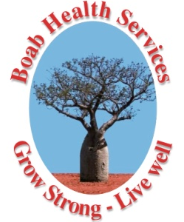
Mental Health Professional
(FTE – Negotiable up to 1 FTE)
Adults, Youth & Families
Kununurra - East Kimberley
($95,744 - $102,925)

A unique and exciting opportunity exists for an experienced Mental Health Professional (i.e. Psychologists, Mental Health Nurses, Social Workers, Occupational Therapists or Aboriginal Health Workers) to join our Mental Health Team. We are seeking professionals who are committed to the delivery of quality Psychological services that meet the mental health needs of our client base in a culturally respectful manner.

This position’s primary focus will be in the provision of services to youth with complex mental health issues. Additionally, it will work across the lifespan providing services to families and adults. The position will be based the township of Kununurra and provide outreach Mental Health services to remote communities in the East Kimberley. The position will work in partnership with local Aboriginal Health Services, WA State Health Services and other community based organisations.

You will have post-registration experience in providing evidence based psychological interventions to youth/adults with complex mental health issues and be able to provide suicide prevention services within your role. This position will also provide support to families of the youth/adults. Your experience, passion, energy and enthusiasm towards Aboriginal, rural and preventative mental health care will be highly regarded.

Benefits include:
- Relocation assistance (where applicable)
- Salary packaging options for remote living are available
- Six weeks annual leave
- Professional development opportunities
- Supported external supervision

For further information and position description please access Boab’s website at www.boabhealth.com.au and go to the positions vacant webpage.

Applicants must forward a response to the selection criteria (located within the job description) together with their resume and the names of at least two referees to: chris.phillips@boabhealth.com.au

Applications close: C.O.B. 16/07/18. We reserve the right to close off this position before the cut-off date should we have a suitable pool of applicants.

Boab Health Services will not provide feedback to applicants who are not shortlisted.

Boab Health Services is an Equal Opportunity Employer who values and encourages diversity within its workforce

