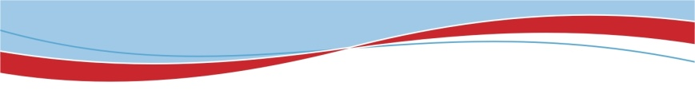
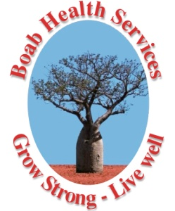
Diabetes Educator
A Unique and Exciting Opportunity
Kununurra - East Kimberley
1FTE
($93,867 - $100,907)

An exciting opportunity exists for an experienced Diabetes Educator to join the Allied Health Team. The role involves the delivery of clinical services and education sessions to staff and communities within the East Kimberley.

This position is based in Kununurra in the northeast of Western Australia and provides a Diabetes Educator service to towns and remote Aboriginal communities in the East Kimberley region. The position works in partnership with local Aboriginal Health Services, WA State Health Services and other community based organisations.

Your experience in Diabetes Education across a variety of health care settings will be highly regarded, as will your passion, energy and enthusiasm towards Aboriginal health, rural health and preventative health care.

Applicants must have appropriate professional registration, a post graduate qualification in Diabetes Education and be credentialed or working towards credentialing with ADEA.

Benefits include:
- Relocation assistance (where applicable)
- Salary packaging, including benefits for remote living
- Professional development opportunities
- 6 weeks annual leave

Interested applicants should phone: Robyn Powell (Allied Health Manager) on (08) 9192 7888 or mobile – 0417 237 097.

For further information and position description please access Boab’s website at www.boabhealth.com.au and go to the “Positions Vacant” webpage.

Applications must address the selection criteria (located within the position description) and email this together with their resume and the names of a least two referees to:
chris.phillips@boabhealth.com.au

Applications close: Close of Business Monday the 12/03/18

Boab Health Services is an Equal Opportunity Employer who values and encourages diversity within its workforce

